TASK 1:

#include<iostream>

using namespace std;

int main() {

int number1, number2;

cout << "Enter the first number: " << endl;

cin >> number1;

cout << "Enter the second number: " << endl;

cin >> number2;

if (number1 > number2)

cout << number1 << " is greater than " << number2;

else

cout << number2 << " is greater than " << number1;

return 0;

}

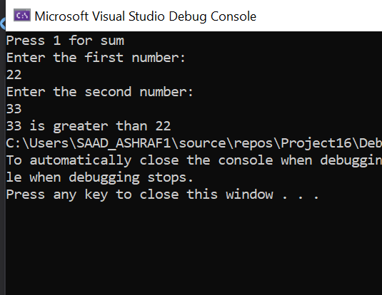

TASK 2:

#include<iostream>

using namespace std;

int main() {

int number1, number2, operation, sum = 0;

cout << "Press 1 for sum" << endl;

cout << "Press 2 for odd or even" << endl;

cout << "Enter the first number: " << endl;

cin >> number1;

cout << "Enter the second number: " << endl;

cin >> number2;

cout << "Enter operation: " << endl;

cin >> operation;

if (operation == 1) {

sum = number1 + number2;

cout << "The sum is " << sum;

}

if (operation == 2) {

if (number1 % 2 == 0) {

cout << number1 << " is even" << endl;

}

if (number1 % 2 != 0)

cout << number1 << " is odd" << endl;

}

if (number2 % 2 == 0) {

cout << number2 << " is even" << endl;

}

if (number2 % 2 != 0) {

cout << number2 << " is odd" << endl;

}

return 0;

}

